A
Mini Project Report (BCS 554) (5th Semester)
On
SmartEats: Digital Canteen Platform
Group No- 41
Submitted
In partial fulfillment
For the award of the Degree of
Bachelor of Technology

In the Department of Computer Science & Engineering

Submitted To:  Mr.Asim kumar Rai  Assistant Professor  CSE Department  IMSEC, Ghaziabad | Submitted By:  Kishan Shamra (2301430100120)  Karan Kr. Maurya (2301430100113)  Jesvin Cherian (2301430100106)  Majid Ali (2301430100133)  Mohd. Sohail (2301430120141)

Department Of Computer Science & Engineering
IMS Engineering College Ghaziabad (U.P)
Dr. A.P.J. Abdul Kalam Technical University Lucknow
Uttar Pradesh
November 2025

Vision and Mission of the Institute and Department

Vision:
To make IMSEC an Institution of Excellence for empowering students through technical education, incorporating human values, and developing engineering acumen for innovations and leadership skills to upgrade society.

Mission:
Mission 1: To promote academic excellence by continuous learning in core and emerging Engineering domains using innovative teaching and learning methodologies.
Mission 2: To inculcate values and ethics among the learners.
Mission 3: To promote industry interactions and cultivate young minds for entrepreneurship.
Mission 4: To create a conducive learning ecosystem and research environment on a perpetual basis to develop students as technology leaders and entrepreneurs who can address tomorrow’s societal needs.
Vision of the Department
To provide globally competent professionals in the field of Computer Science & Engineering embedded with sound technical knowledge, aptitude for research and innovation, and nurture future leaders with ethical values to cater to the industrial & societal needs.
Mission of the Department
Mission 1: To provide quality education in both the theoretical and applied foundations of Computer Science & Engineering.
Mission 2: Conduct research in Computer Science & Engineering resulting in innovations thereby nurturing entrepreneurial thinking.
Mission 3: To inculcate team building skills and promote life-long learning with a high societal and ethical values.

Program Outcomes (POs) and Program Specific Outcomes (PSOs)
S. No. | Program Outcomes / Program Specific Outcomes
PO1. | Engineering knowledge: Apply the knowledge of mathematics, science, engineering fundamentals, and an engineering specialization to the solution of complex engineering problems.
PO2. | Problem analysis: Identify, formulate, review research literature, and analyze complex engineering problems reaching substantiated conclusions using first principles of mathematics, natural sciences, and engineering sciences.
PO3. | Design/development of solutions: Design solutions for complex engineering problems and design system components or processes that meet the specified needs with appropriate consideration for the public health and safety, and the cultural, societal, and environmental considerations.
PO4. | Conduct investigations of complex problems: Use research-based knowledge and research methods including design of experiments, analysis and interpretation of data, and synthesis of the information to provide valid conclusions.
PO5. | Modern tool usage: Create, select, and apply appropriate techniques, resources, and modern engineering and IT tools including prediction and modelling to complex engineering activities with an understanding of the limitations.
PO6. | The engineer and society: apply reasoning informed by the contextual knowledge to assess societal, health, safety, legal and cultural issues and the consequent responsibilities relevant to the professional engineering practice.
PO7. | Environment and sustainability: Understand the impact of the professional engineering solutions in societal and environmental contexts, and demonstrate the knowledge of, and need for sustainable development.
PO8. | Ethics: Apply ethical principles and commit to professional ethics and responsibilities and norms of the engineering practice.
PO9. | Individual and team work: Function effectively as an individual, and as a member or leader in diverse teams, and in multidisciplinary settings.
PO10. | Communication: Communicate effectively on complex engineering activities with the engineering community and with society at large, such as, being able to comprehend and write effective reports and design documentation, make effective presentations, and give and receive clear instructions.
PO11. | Project management and finance: Demonstrate knowledge and understanding of the engineering and management principles and apply these to one’s own work, as a member and leader in a team, to manage projects and in multidisciplinary environments.
PO12. | Life-long learning: Recognize the need for, and have the preparation and ability to engage in independent and life-long learning in the broadest context of technological change.

CSE Department Program Educational Objectives (PEOs)

B. Tech Computer Science & Engineering Department has the following Program Educational Objectives:

PEO1: Possess core theoretical and practical knowledge in Computer Science and Engineering for successful career development in industry, pursuing higher studies or entrepreneurship.
PEO2: Ability to imbibe life long learning for global challenges to impact society and environment.
PEO3: To demonstrate work productivity with leadership and managerial skills having ethics and human value in progressive career path.
PEO4: To exhibit communication skill and collaborative skill plans and participate in multidisciplinary Computer Science & Engineering fields .

CSE Department Program Specific Outcomes (PSOs)

B.Tech Computer Science & Engineering Department has the following Program Specific Outcomes:

PSO1: To analyze and demonstrate, the recent engineering practices, ethical values and strategies in real time world problems to meet the challenges for the future.
PSO2: To develop adaptive computing system using computational intelligence strategies and algorithmic design to address diverse data analysis and machine learning challenges.

CO-PO-PSO MAPPING FOR ACADEMIC SESSION 2025-26
Course Name: Mini Project Course Code: BCS-554
Semester / Year: 5th / 3 NBA Code: C310
Faculty name(s): Ms. Meenu Sharma/ Ms. Vandana Tomar
Course Outcomes:
Sl.NO | DESCRIPTION | COGNITIVE LEVEL (BLOOMS TAXONOMY)
C310.1 | Developing a technical artifact requiring new technical skills and effectively utilizing a new software tool to complete a task | K3
C310.2 | Writing requirements documentation, Selecting appropriate technologies, identifying and creating appropriate test cases for systems. | K4
C310.3 | Demonstrating understanding of professional customs & practices and working with professional standards. | K2
C310.4 | Improving problem-solving, critical thinking skills and report writing. | K5
C310.5 | Learning professional skills like exercising leadership, behaving professionally, behaving ethically, listening effectively, participating as a member of a team, developing appropriate workplace attitudes | K6

CO-PO-PSO Mapping:
 | PO1 | PO2 | PO3 | PO4 | PO5 | PO6 | PO7 | PO8 | PO9 | PO10 | PO11 | PO12 | PSO1 | PSO2
C310.1 | 3 | 3 | 3 | 3 | 3 | 2 | 1 | 2 | 2 | 2 | 2 | 3 | 3 | 3
C310.2 | 3 | 3 | 2 | 2 | 2 | 1 | 1 | 2 | 2 | 3 | 1 | 1 | 2 | 3
C310.3 | 1 | 1 | 1 | 1 | 1 | 3 | 2 | 3 | 2 | 2 | 2 | 2 | 2 | 1
C310.4 | 3 | 3 | 3 | 3 | 3 | 2 | 1 | 1 | 2 | 3 | 1 | 3 | 1 | 1
C310.5 | 1 | 1 | 1 | 1 | 1 | 2 | 2 | 3 | 3 | 3 | 3 | 1 | 1 | 1
C310 | 2.20 | 2.20 | 2.00 | 2.00 | 2.00 | 2.00 | 1.40 | 2.20 | 2.20 | 2.60 | 1.80 | 2.00 | 1.80 | 1.80

Candidate’s Declaration

I hereby declare that the work, which is being presented in the Mini Project (BCS 554), titled “SmartEats: Digital Canteen Platform” is being submitted for the partial fulfillment for the Mini project work in 5th semester for the award of “Bachelor of Technology” in the Department of Computer Science & Engineering, IMS Engineering College, Ghaziabad, affiliated to Dr. A.P.J. Abdul Kalam Technical University, Lucknow, Uttar Pradesh. This mini project work is a record of my own investigations carried under the Guidance of Mr Asim Kumar Rai, Assistant Professor IMS Engineering College, Ghaziabad.

I have not submitted the project work presented in this Mini project anywhere for the award of any other Degree.

Jesvin Cherian  2301430100106 | Karan Kr Maurya  2301430100113
Majid Ali  2301430100133 | Kishan Sharama  2301430100120
Mohd Sohail
2301430100140

CERTIFICATE

This is certified that the Mini Project Report titled “SmartEats: Digital Canteen Platform” submitted by Mohd Sohail , Jesvin Cherian, Karan Kr. Maurya, Kishan Sharma, Majid Ali in the Department of Computer Science and Engineering, IMS Engineering College, Ghaziabad, affiliated to Dr. A.P.J. Abdul Kalam Technical University, Lucknow, Uttar Pradesh for the award of the Degree of Bachelor of Technology in Computer Science & Engineering is a record of bonafide work carried out by him/her/them under my supervision. In my opinion, the 5th Semester Mini Project Report has reached the standards of fulfilling the requirements of the regulations of Degree.
.

Mr. Asim Kumar Rai
Assistant Professor
CSE Department
IMS Engineering College,Ghaziabad

ACKNOWLEDGEMENT
First and foremost, I would like to express my sincere gratitude to my Mini Project Supervisor Mr. Asim Kumar Rai, Assisant Professor CSE Department, IMS Engineering College, Ghaziabad, who gave me this opportunity with important guidelines regarding various points to be taken for my Mini Project work and also for his deep involvement, precious advice, invaluable suggestions and continuous motivation throughout this work. I am highly obliged to him for always being there for my needs. I consider myself very fortunate for having been associated with a Mentor like him. His affection, guidance, and scientific approach served as a veritable incentive for the completion of this work.

I am extremely thankful to Prof. (Dr.) Manas Kumar Mishra, Director, IMSEC, Ghaziabad, for providing me with infrastructural facilities to work in, without which this work would not have been possible.

I express my sincere gratitude to Prof. (Dr.) Sonali Mathur, HoD (CSE), IMSEC, Ghaziabad, for his stimulating guidance, continuous encouragement, and supervision throughout the course of the present work.

I would also like to express my genuine gratitude to Mr. Meenu Sharma and Ms. Vandana Tomar, Mini Project Coordinator for their valuable suggestions and advice in carrying out this work.

I also like to thank the entire department faculty who helped me directly or indirectly to complete my work. This acknowledgment will remain incomplete if I fail to express my deep sense of obligation to my family and God for their consistent blessings and encouragement.

Table of Contents

S.NO. | CONTENTS | PAGE NO
1. | Vision and Mission | 1
2. | Candidate’s Declaration | 2
3. | Certificate | 3
4. | Acknowledgement | 4
5. | Table of Contents | 5
6. | List of Figures | 6
7. | List of Tables | 7
8. | Chapter 1 INTRODUCTION | 8
 | 1.1 Background | 9
 | 1.2 Objective | 10
 | 1.3 Scope of Project | 11
 | 1.4 Problem Statement
9. | Chapter 2 LITERATURE SURVEY
10. | Chapter 3 METHODOLOGY
 | 3.1 Problem Definition
 | 3.2 Data Flow Diagram
 | 3.3 Tools and Technology Used
11. | Chapter 4 IMPLEMENTATION
12. | Chapter 5 FUTURE SCOPE & CONCLUSION
 | 5.1 Limitation of the System
 | 5.2 Future Scope
 | REFERENCES

List of Figures
Figure No. | Figure Name | Page No.
3.1 | Data Flow Diagram
4.1 | Flow Diagram of Implementation
4.2 | Customer home page
4.3 | Menu and order section
4.4 | Order status & history
4.5 | Customer login/Register page
4.6 | Daily sales analytics dashboard
4.7 | Menu management
4.8 | Admin list of items
4.9 | Admin list of orders
4.10 | Real time order management

CHAPTER 1
INTRODUCTION

1.1 Background
SmartEats traditional canteens in educational institutions and offices often rely on manual processes for taking orders, managing inventory, and handling payments. This approach can lead to long queues, delays, billing errors, stock shortages, and a lack of transparency. As the number of users grows, these problems become more pronounced, affecting both the efficiency of canteen operations and the satisfaction of students and staff.
1.2 Objective
The objective of the SmartEats Digital Canteen Platform is to automate canteen operations, reducing the manual workload involved in order processing, billing, and inventory management. By digitizing these tasks, the system ensures smoother and faster operations for both staff and users. Another objective is to improve the user experience by allowing students and staff to place orders quickly and efficiently through an online platform, minimizing waiting time and inconvenience.
1.3 Scope of Project
The scope of the SmartEats Digital Canteen Platform aims to streamline and automate canteen operations for educational institutions and offices. It enables online ordering, reducing wait times and minimizing manual errors in order processes. The system provides real-time inventory management, helping staff track stock and prevent wastage efficiently. Secure digital payments and detailed analytics offer transparency, convenience, and insights into sales trends and popular items. Additionally, the system is scalable and can be enhanced in the future with features like AI-based recommendations, loyalty programs, and mobile app integration.
1.4 Problem Statement
Traditional canteen management systems in educational institutions or offices face several challenges such as long queues, manual order taking, inaccurate billing, inventory mismanagement, and a lack of transparency. Students and staff often waste time waiting for their orders, while canteen staff struggle to track inventory, manage payments, and generate sales reports efficiently. These inefficiencies negatively impact the overall user experience and hinder smooth canteen operations.

CHAPTER 2

LITERATURE SURVEY

In 2021, Meher et al. [1] introduced one of the earliest frameworks for canteen automation, focusing on replacing manual operations with web and mobile technologies. Their study emphasized efficiency gains and reduction of human error, laying the foundation for later digital transformation in food service environments.

Building on this, Sharma et al. [2] in 2022 explored self-service kiosks and mobile ordering platforms, demonstrating significant improvements in queue management, order accuracy, and customer satisfaction compared to traditional over-the-counter systems.

Holkar et al. [3] in 2023 advanced the field by integrating cloud-based smart canteen systems for university campuses. Their work highlighted scalability, real-time data synchronization, and the potential of cloud computing to support cashless transactions and transparent financial records.

In 2024, Kadam et al. [4] investigated automation for operational efficiency, focusing on real-time tracking technologies such as web sockets and push notifications. Their findings showed reduced congestion and improved communication between kitchen staff and customers, further enhancing the dining experience.

Finally, Yadav et al. [5] presented Food Flex, a comprehensive automation solution that incorporated forecasting, inventory management, and waste reduction strategies. Their study demonstrated how predictive analytics could minimize food waste while optimizing order planning, representing a mature stage of canteen automation.

CHAPTER 3

METHODOLOGY
3.1 Problem Definition
The current canteen system faces problems like long queues, slow service, and manual order mistakes. Students often wait longer because there is no digital system for viewing menus or placing orders. Payments and billing also take more time because everything is done manually. To solve this, the project aims to design an online system where users can order food, make payments, and track order status easily. The final system makes canteen operations faster, easier, and more organized
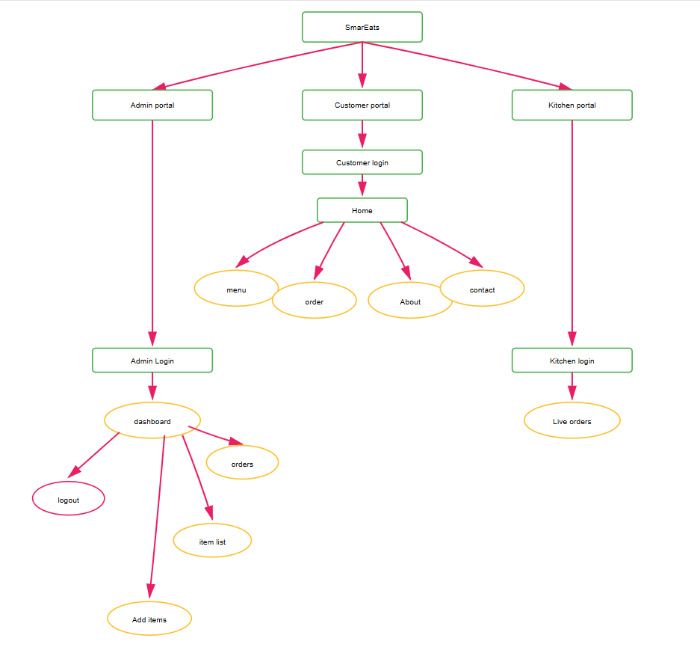
3.1 Data Flow Diagram

Figure 3.1: The figure represents the Navigation Flow of the SmartEats Digital Canteen Management System. It demonstrates how users access the application through role-based login and are redirected to different portals — Customer, Admin, and Kitchen — based on their credentials. Customers can browse the menu, place orders, view order history, and access support information through the Home interface. The Admin panel allows managing food items, monitoring customer orders, and maintaining inventory. The Kitchen portal enables staff to track and process live orders efficiently. The structure ensures smooth interaction, clear accessibility, and streamlined operational flow across all user roles.

3.3 Tools and Technology Used
The project employs a combination of hardware and software tools to create a responsive and functional automated canteen system.
Software Tools:
- Frontend: HTML, CSS, JavaScript
- Backend: Node.js, Express.js
- Database: MongoDB
- Authentication: Login/Signup, Customer, Kitchen, Admin (Role-based access)
- API Services: Registration, Login, Logout, Order Management, Inventory Management, Role-based APIs
- Version Control: Git & GitHub
Hardware Requirements:
- Processor: Intel i5 or equivalent
- RAM: Minimum 8 GB
- Storage: SSD preferred, 256 GB or more
- Internet Connection: Required for online functionalities and updates

CHAPTER 4
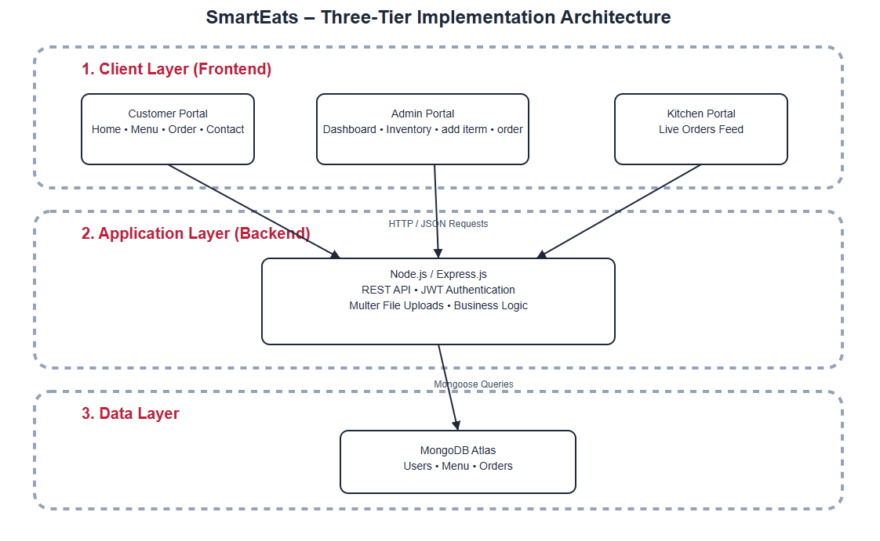
IMPLEMENTATION

Figure 4.1: Flow Diagram of Implementation
Figure 4.1 illustrates the implementation workflow of the SmartEats Digital Canteen System, showing how customers, administrators, and kitchen staff access their respective portals through secure authentication. The frontend communicates with the backend via RESTful APIs for handling menu operations, order processing, and inventory updates. All data is stored and managed in MongoDB Atlas for fast and reliable access.
This three-tier architecture ensures smooth communication between modules, efficient kitchen operations, and centralized system administration. The layered structure improves scalability, performance, and maintainability of the entire system.

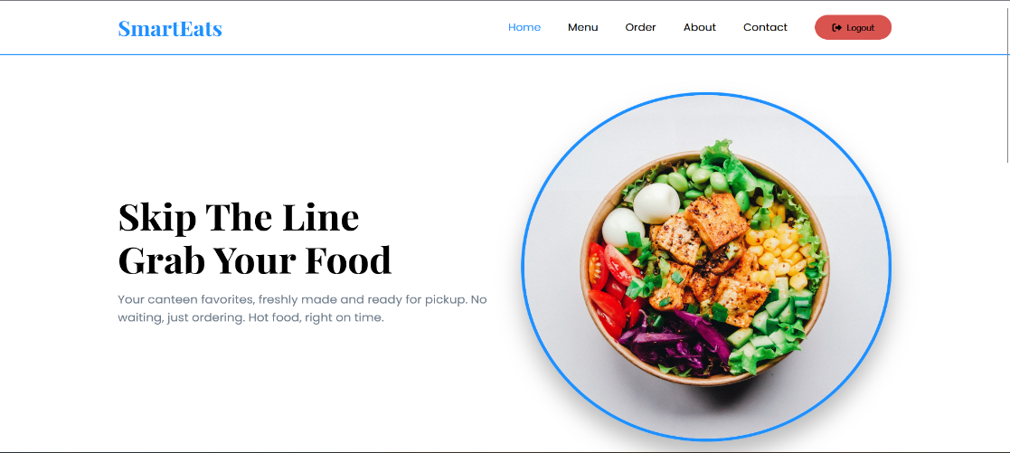
Figure 4.2 Customer home page
Figure 4.2 A seamless digital canteen platform that lets users skip queues and instantly pick up freshly prepared meals. SmartEats offers fast ordering, real-time updates, and a smooth, modern food-pickup experience

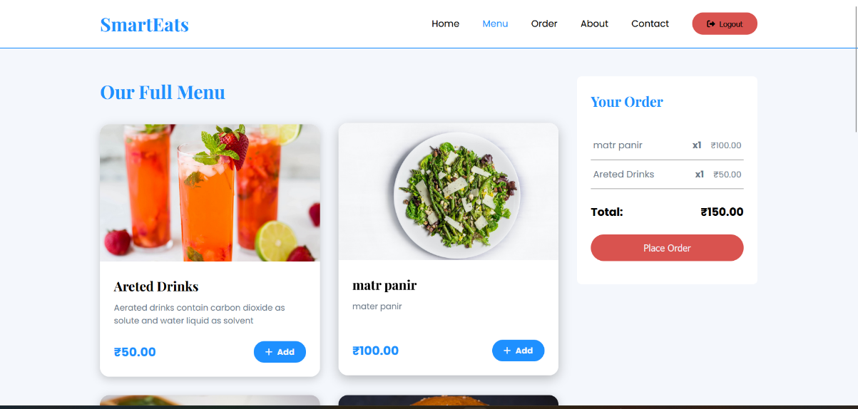
Figure 4.3 Menu and order section
Figure 4.3 A smart, user-friendly menu interface that lets customers browse dishes, add items instantly, and view their order summary in real time. SmartEats makes food selection smooth, transparent, and effortless.

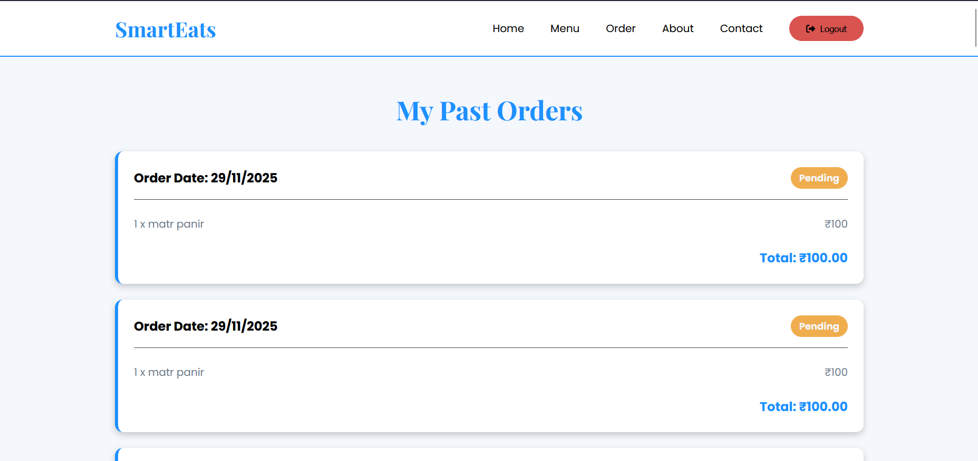
Figure 4.4 Order status & history

Figure 4.4 A clean and user-friendly interface where customers can view their past orders along with order dates and item details. The order status is clearly displayed to keep users updated. This feature provides transparency and easy access to order history for future reference.

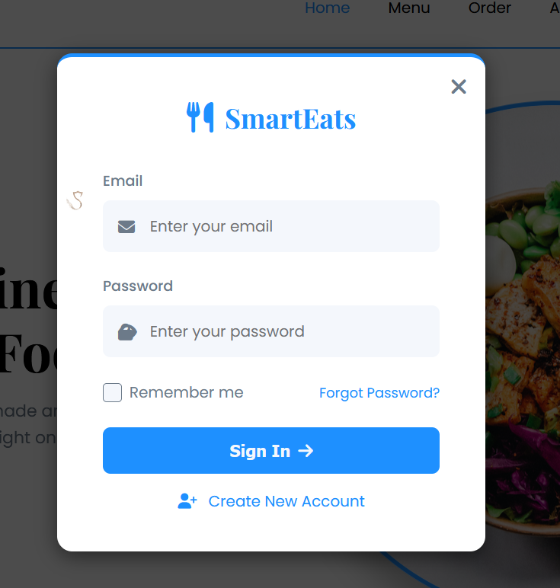

Figure 4.5 Customer login/Register page

Figure 4.5 depicts a secure and intuitive login interface that allows users to quickly access their SmartEats account. Designed with a clean layout for smooth sign-in, password recovery, and easy account creation.

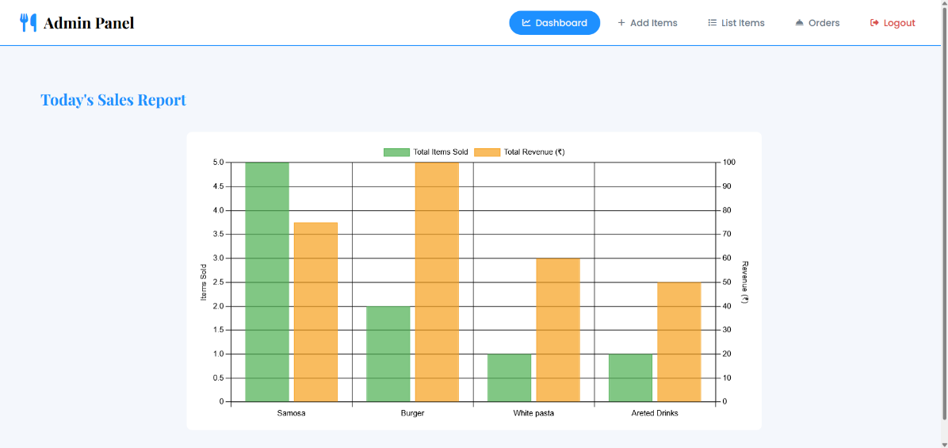

Figure 4.6 Daily sales analytics dashboard
Figure 4.6 depicts A detailed sales analytics dashboard that displays total items sold and revenue generated for each food category. This visual report helps admins track daily performance and make data-driven decisions

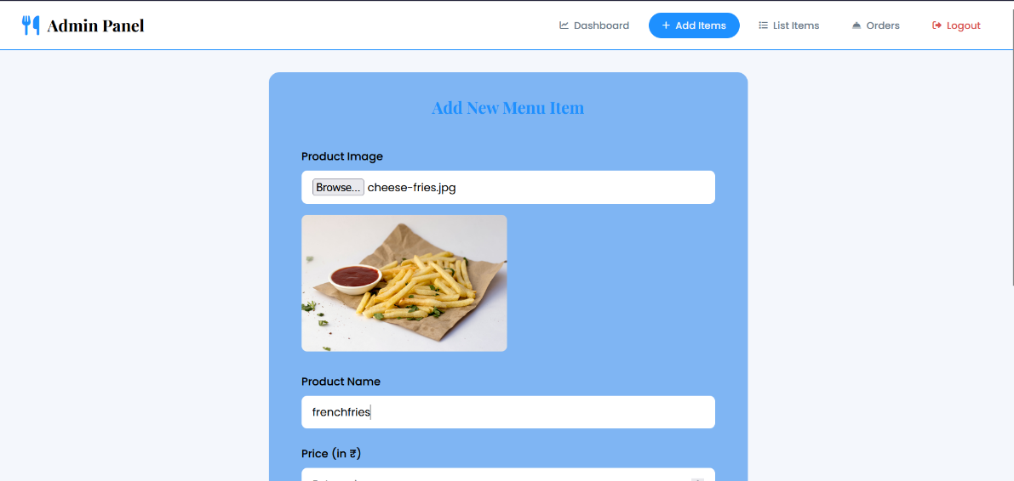
Figure 4.7 Menu management

Figure 4.7 depicts a dedicated admin interface that allows uploading product images, entering item details, and setting prices to seamlessly add new dishes to the SmartEats menu. Designed for quick, efficient, and accurate menu management.

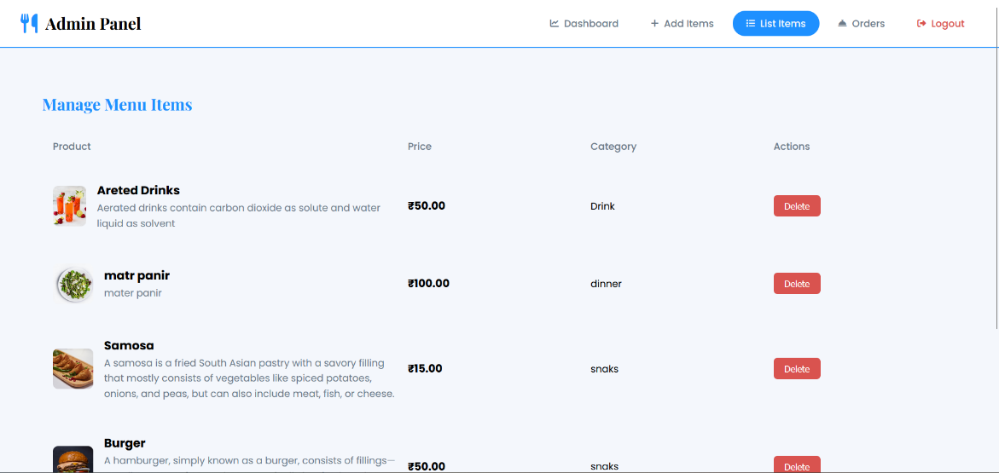
Figure 4.8 Admin list of items

Figure 4.8 A streamlined management panel where admins can view all menu items along with their prices and categories, ensuring efficient oversight. The interface also allows quick deletion of items to keep the menu updated and accurate

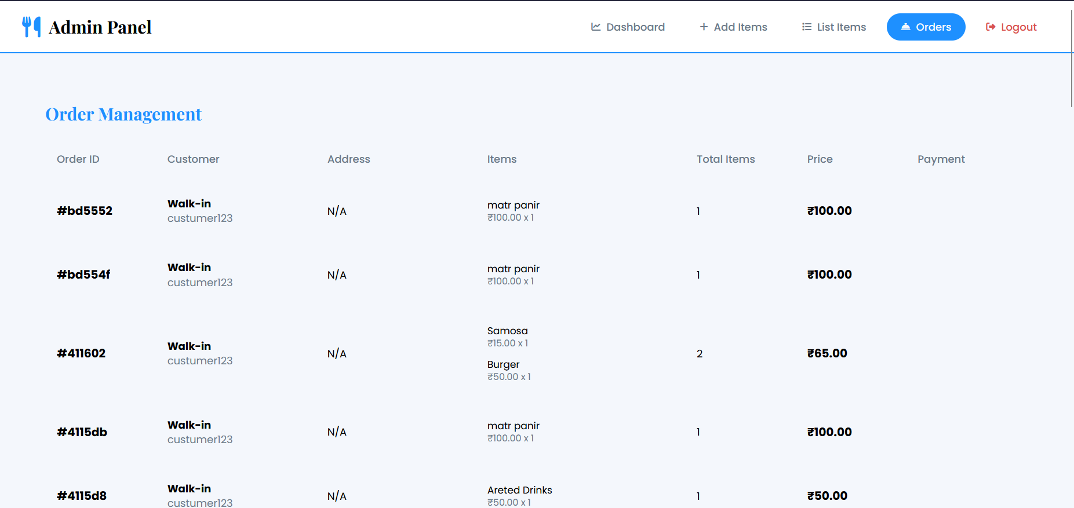
Figure 4.9 Admin list of orders

Figure 4.9 An organized order management panel where admins can view all customer orders with essential details such as items, quantity, and price. The interface helps in monitoring order status effectively. It ensures smooth coordination between admin and kitchen staff for timely order processing.

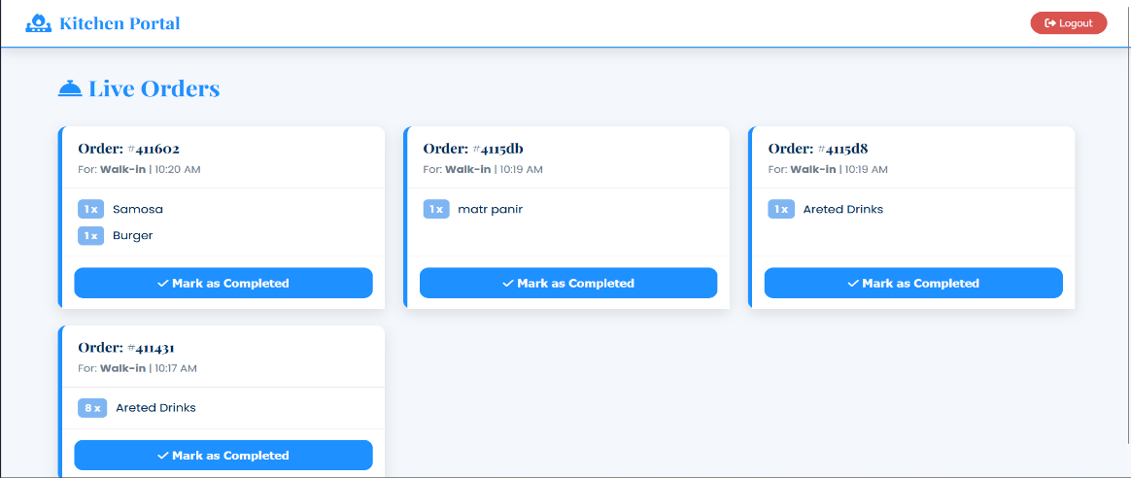

Figure 4.10 Real time order management

Figure 4.10 depicts a real-time kitchen dashboard displaying all active customer orders with item details and timestamps. Staff can efficiently track, prepare, and update order status using the “Mark as Completed” feature.

CHAPTER 5

FUTURE SCOPE & CONCLUSION
4.1 Limitations of the System
The SmartEats Digital Canteen System is a centralized platform for managing ordering and payment processes. During peak hours, delays may still occur due to kitchen capacity limitations, even if the ordering is digital. Users who are not familiar with technology may also face difficulties in using the system effectively. Additionally, server downtime or hardware failures can temporarily disrupt the workflow.

• Heavy Dependency on Internet Connectivity
SmartEats requires stable internet access for real-time data synchronization, analytics, and dashboard updates.
Without connectivity:
- Users cannot browse the menu or place orders
- Real-time monitoring becomes unavailable
- Collaboration tools fail to operate efficiently
This limitation affects rural or developing regions where reliable network infrastructure is lacking.

• Integration Complexity of Multiple Data Sources
The system combines multiple data components like inventory, orders, and user accounts, which increases operational complexity.
Challenges include:
- Managing high traffic during peak hours
- Data consistency and synchronization issues
- Dependency on external APIs may cause delays or security concerns
These issues can affect the accuracy and reliability of system analytics and reports.

Limitations include:
1. Lack of predictive intelligence
2. Minimal automation in decision-making
3. No adaptive learning from user behavior
This restricts advanced forecasting and strategic recommendations.

• Dependence on Third-Party APIs and Rate Limitations
The system relies on third-pary APIs for payment processing and real-time data, making it dependent on their availability and performance, they impose:
• Payment Gateway Integration: Uses third-party APIS (like Razorpay or PayPal) to process online payments securely and efficiency.
• Real-Time Data Services: Relies on external APIs for menu updates, order tracking, or notifications, ensuring up-to-date informations.
This reliance creates a bottleneck in the system, where the assistant’s performance is dictated by external services beyond the developer’s control.

• Challenges with SmartEats system
Auth utilizes the Web API to enable SmartEats Digital Canteen System, which enhances the user experience. However, this feature comes with significant drawbacks:
• Handling High Traffic During Peak Hours: During busy times, many students place orders simultaneously, which can slow down the system and affect response time if the server is not optimized.
• Ensuring Real-Time Data Synchronization: Keeping menu updates, order statuses, and inventory changes synchronized all users in real time is challenging and requires efficient backend communication.
These challenges make the SmartEats feature unreliable in many real-world scenarios, particularly for users who rely heavily on voice commands for convenience.

Additional Areas of Concern Lack of Advanced Features
While Auth is functional for basic tasks, it lacks advanced capabilities such as:
• The system does not incluse AI-based features.
• Advanced analytics and reporting tools for deep business insights are not available.
• The system lacks integration with IoT.

Scalability and Expandability
As the system is built using static web technologies (HTML, CSS, JavaScript), expanding its functionality or integrating advanced features (e.g., natural language processing, AI, or databases) would require significant redevelopment.

Conclusion
The Smarts Canteen Management System automates ordering, payments, reducing manual work and errors. It improves efficiency for students, staff, and administrators while providing a convenient user experience. Its modular design allows scalability and easy addition of new features in the future. Overall, the project demonstrate how technology can stream line canteen management and improve service quality:
1.Here we can automates ordering, payments, and inventory, reducing manul errors.
2.Improves efficiency and convenience for students, staff amd administrator.
3.Can be enhanced in the future with AI, analytics, and real-time tracking.
4.Demonstrates how technology streamlines canteen operations and improve service.

4.2 Future Scope
The Cipher virtual assistant has substantial potential for improvement and scalability: 1. Mobile App Integration: Develop Android/iOS apps for easir ordering notifications, and tracking.
2. AI-Based Recommendations: Suggest dishes based on user preference and past orders.
3. Contactless Payments: Implement NFC, UPI, or QR code-based payment for faster transactions.

4. IoT Integration: Smart kitchen divices to monitor cooking, stock, and temperature automatically.
5. Sustainability Tracking: Monitor food wastage, energy usage, and eco-friendly initiatives.
6. Predictive Inventory Management: Use analytics to predict stock need and reduce wastage.
7. Data Privacy and Security: Implementing robust mechanisms to safeguard user data and ensure compliance with privacy regulations would increase user trust.

REFERENCES

- A. Meher, D. Shah, U. Kokate, D. Mehta, and N. Shinde, “Canteen Automation System,” International Journal for Research in Applied Science and Engineering Technology (IJRASET), vol. 9, no. 5, pp. 1235–1242, May 2021. doi: 10.22214/IJRASET.2021.34506.

- S. Sharma, V. Sharma, N. Pandey, and T. Garg, “Automated Canteen Ordering System,” International Journal for Research in Applied Science and Engineering Technology (IJRASET), vol. 10, no. 5, pp. 43173–43180, May 2022. doi: 10.22214/IJRASET.2022.43173.

- A. Holkar, A. Gohil, C. Soni, and A. Gadekar, “Implementation of a Smart Canteen System for University Campus Using Cloud,” Journal of Emerging Technologies and Innovative Research (JETIR), vol. 10, no. 6, pp. 263–270, Jun. 2023.

[4] S. Kadam, V. Kondhalkar, Y. Dandegaonkar, K. Purswani, and M. Sabnis, “Canteen Automation System,” International Journal of Creative Research Thoughts (IJCRT), vol. 12, no. 3, pp. 764–770, Mar. 2024.

